Request for Proposals
Wood Chip Heating Fuel Supply

(Name of facility or end user) located at (address of facility) is seeking bids for the delivery of wood chip heating fuel supply for wood-fired boiler(s) located at _______________________ for the period, (month 20__ through (month) 20__ . (Name of facility or end user) anticipating using a total of approximately _____ tons per year of wood chip fuel meeting the ANSI/ASABE AD17225-4:2014 FEB2018 Solid biofuels -- Fuel specifications and classes -- Part 4: Graded wood chip heating fuel technical quality standard for Grade (A1, A2, B) chips (hereafter, AD17225-4 Standard), with use and schedule of delivery determined by actual heating needs. A copy of the standard is available by email order at OrderStandard@asabe.org.. A summary of the standard can be downloaded from - www.woodchipstandard.org.

(Name of facility or end user) will require wood chip heating fuel beginning in _______ 201_. (Name of facility or end user) prefers bids that cover the next (two or three) heating seasons (July to June for the years 20__-20__, 20__-20__, and 20__-20__), at a known or formula-based price, but will entertain all proposals (including single year bids).

About the Facility
_____________ operates a ____ MMBTU/hr wood chip boiler manufactured by _____________ to heat approximately _________ square feet of building area.

Wood chip fuel is delivered via (live floor trailer/dump truck/blower truck) to a covered unloading and storage bin with a capacity of ___ tons. No more than ___ tons can be off-loaded at any time. Permissible unloading hours are __ AM to __ PM, __ days per week. Trucks must exercise caution when entering and exiting the facility (can add additional stipulations here regarding access to/egress from facility and pedestrian/vehicle traffic). See attached map for site detail.

Bidders may inspect and verify delivery location(s), at their option. To arrange a site visit, please contact:

_______________ (name)
_______________ (address)

(Name of facility) estimates the need for approximately ____ tons of wood chip fuel annually. Fuel must meet or exceed technical fuel quality standards of Grade (select A1, A2, B – see grade illustration on next page) of the AD17225-4 Standard.

The general physical and chemical parameters that fuel must meet or exceed are summarized as follows (details depend on which grade is specified):

- Particle size – select size class (P9.5S, P16S, P25S, P38S, P50S)
- Moisture content – select moisture class (M13, M25, M30, M35, M50)
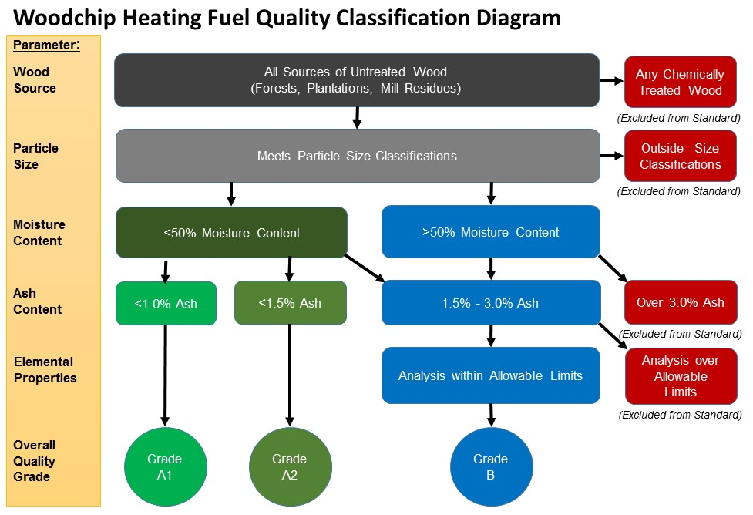
- Inorganic ash content – select ash class (A1.0, A1.5, A3.0

Wood chip fuel must be clean and free of any non-wood contaminants including soil, rocks, plastic, metal, chemically treated wood etc.

Evidence of compliance with this standard must be submitted with this bid in the form of independent third party test data certifying that wood chip fuel meets these minimum specifications, conducted within the last two months. The (name of facility) reserves the right to request a sample and conduct an independent third party test to verify compliance.

All bids MUST be received by ____ PM on ______ ___, 20__ using the attached bid form.

Questions regarding this request for bids should be directed to:

____________ (name and title)
____________ (phone)
____________ (email)

Bid Form – Wood Chip Supply
(Name of Facility)

Bids for fuel supply to (name of facility) must utilize this bid form, and can be emailed to _____________________ or mailed to

____________________________
____________________________
____________________________

The undersigned, having become thoroughly familiar with the quality standard and product specifications, delivery infrastructure and conditions affecting the cost and logistics of wood chip delivery, hereby proposes to deliver the necessary fuel (up to 120% of the anticipated volume of ______ tons per year) in strict accordance with the standards in the attached Request for Proposals for the following sum of money:

Year | Contract Period | Bid Amount ($/ton, delivered)
1 | July 1, 20__ – June 30, 20__
2 | July 1, 20__ – June 30, 20__
3 | July 1, 20__ – June 30, 20__

Please explain any proposed adjustments or other factors (e.g., escalators, diesel adjustment, etc.):

______________________________________________________________________________

______________________________________________________________________________

______________________________________________________________________________

Expected method of delivery (please check): ___ Live floor trailer ___ Dump truck ___ Blower truck

Please summarize approximate delivery rate _______ tons/hour

Expected capacity of delivery truck ______ tons at specified moisture content

Please attach independent third party lab results documenting that fuel meets or exceeds minimum physical and chemical quality parameters for Grade (A1, A2, B) chips AD17225-4 Standard.

The undersigned acknowledges that this bid will remain open and not withdrawn for a period of thirty (30) calendar days from June __, 20__.

Signature: ______________________________________ Date: ____________________

Name: _________________________________________ Title: ____________________

Company Name: _____________________________________________________________

Business Address: ____________________________________________________________

Phone: __________________________ e-mail: ___________________________

All bids MUST be received by __ PM on (date), 20__

Insert map here

